|  |  |
| --- | --- |
|  |  |
| cid:image024.png@01CE3435.D78287D0 |  |
| ses |  |
| ***Key Enablers of Operational Excellence for Americas PSS Service Delivery.*** |  |

**Elicitation session #2**

* **How might we meet the business need?**
  + Developing a software solution to automate and simplify project management.
* **How will we know requirements are complete?**
  + When the allocation formulas summarize at the end of the month and the forecast allocation can be compare with the actual allocation
* **Will the system help you be more efficient? How?**
  + Yes, it will. For Delivery, it will decrease the time invested in manual calculations every time we want to run a report. For the Pas, it will be faster to track the time invested in each project by just adding the hours worked and the tool will automatically calculate the time invested by all the PAs in Delivery Projects at the end of the month, releasing time from the current Capability Portfolio Contact at the end of the month when doing the Actuals Report. For both, it will be a single tool in where you can storage data (important documents related to the project) that will be helpful as historical data and also to provide good support in case a backup is needed.
* **Who will use this feature?**
  + PSS Delivery + Purchases Assistants (Service Delivery and/or Capability) + Service Management
* **Who will deliver the inputs for the feature?**
  + Laura Rojas / Esteban Cortinez
* **Who will receive the outputs of the feature?**
  + PSS Delivery + Capability to provide good visibility to the PSS LT
* **Who can I ask to learn more about this?**
  + Laura Rojas / Esteban Cortinez
* **Are there any exceptions or unusual cases that you sometimes have to do deal with in this process?**
  + No
* **What are the deliverables?** 
  + Monthly FTE allocation Reports
  + Track of Resource Allocation for Projects
  + Storage Data
* **What will the new solution accomplish that is not currently accomplished manually or with other solution?**
  + Storage of data, automatic resource allocation calculation and exact formulas to calculate the resource allocation
* **What needs to be tracked?**
  + Resource Allocation for PSS Contacts )PSS Delivery + Purchases Assistants (Service Delivery and/or Capability) + Service Management)
  + Data Storage for Projects
* **How will we know this is complete?**
  + When the allocation formulas summarize at the end of the month and the forecast allocation can be compare with the actual allocation

**Propousal:**

* Winform with tab for every phase of the project
  + Mapping and matching
  + Transactional work((BAT - Only SD) (CO - Include Infosys SLAs))
  + Hyper care
  + Meeting time
  + Scope
  + Expertise
* Data requirement for each tab
  + ~~Start date~~
  + ~~End date~~
    - Mapping and matching
  + Hours committed – Manual input
  + Allocation – calculated field[1]*
  + Data grid view
    - Resource ID
    - Resource description
    - Hours
    - Monthly FTE(formula)
    - Month[2]
    - Owner
    - Owner name
    - Transactional work
  + Allocation - calculated field[3]*
  + Data grid view
    - Resource ID
    - Resource description
    - Hours
    - Monthly FTE(formula)
    - Month[4]
    - Add column for transactional event.
      * SIT
      * BAT
      * TCO
      * CO
    - Volume
    - Input type (Pick list):
      * Materials
        + Add to pick list “Material”
        + Add to pick list “Hours”
      * ~~Purchase orders~~
      * ~~Vendors~~
      * ~~Invoices~~
    - Value
    - Owner
    - Owner name
    - Hyper care
  + Hours committed – Manual input
  + Allocation – calculated field[5]*
  + Data grid view
    - Resource ID
    - Resource description
    - Hours
    - Monthly FTE(formula)
    - Month[6]
    - Owner
    - Owner name
    - Meeting time
  + Hours committed – Manual input
  + Allocation – calculated field
  + Data grid view
    - Resource ID
    - Resource description
    - Hours
    - Monthly FTE(formula)
    - Month[7]
    - Owner
    - Owner name
    - Scope
  + Hours committed – Manual input
  + Allocation – calculated field
  + Data grid view
    - Resource ID
    - Resource description
    - Hours
    - Monthly FTE(formula)
    - Month[8]
    - Owner
    - Owner name
    - Expertise
  + Hours committed – Manual input
  + Allocation – calculated field
  + Data grid view
    - Resource ID
    - Resource description
    - Hours
    - Monthly FTE(formula)
    - Month[9]
    - Owner
    - Owner name

**Other information:**

* Data grid resources:
  + PSS Project Manager
  + PMaaS
  + Service Management Contact
  + Service Delivery Contact - R&P
  + Service Delivery Contact – Logistics
  + Service Delivery Contact – SS
  + Service Delivery Contact – STR
  + Contractor – TTS
  + Development Resource
* Formula for FTE:
  + Entry type hours: FTE = hours / 173.33
  + Entry type materials: FTE = (Materials * (0.033 / 60)) / 173.33)

**Form drawing:** 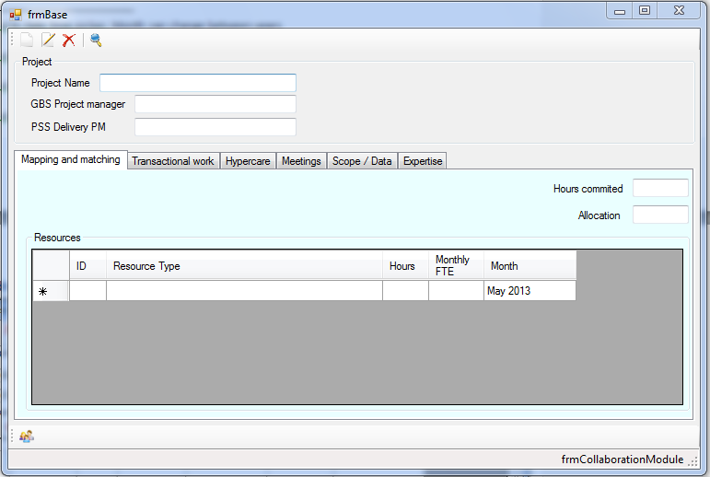

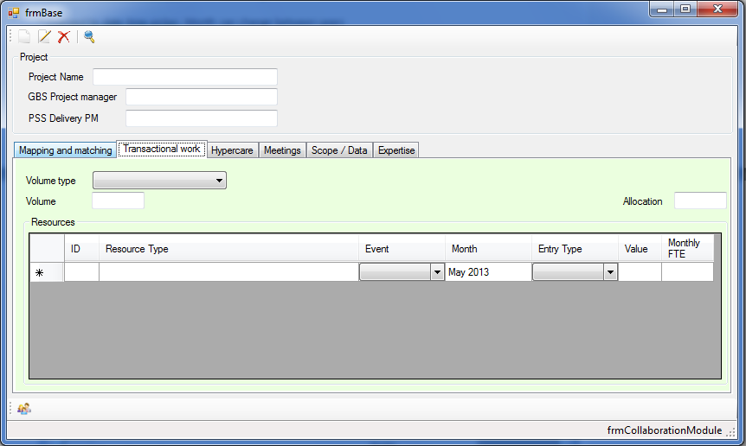

**New input for tasks:**

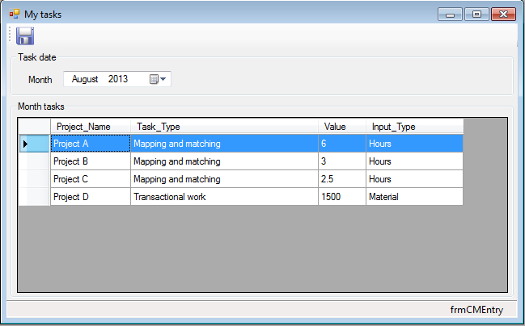

1. * Formulas will be shared by Laura Rojas and Esteban Cortinez
2. Changed to date time picker. Month can change between years
3.
4. Changed to date time picker. Month can change between years
5.
6. Changed to date time picker. Month can change between years
7. Changed to date time picker. Month can change between years
8. Changed to date time picker. Month can change between years
9. Changed to date time picker. Month can change between years